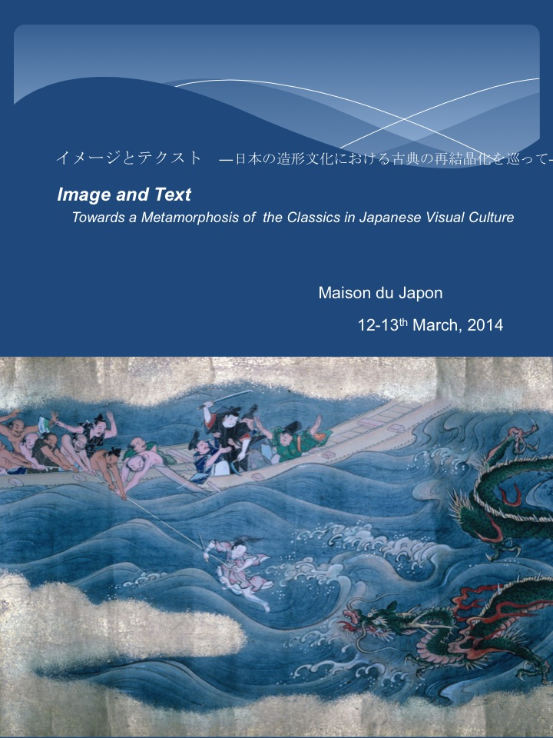

イメージとテクスト
―日本の造形文化における古典の再結晶化を巡って―

Image and Text
Towards a Metamorphosis of the Classics in Japanese Visual Culture

An international workshop organised by Midori Sano (Gakushuin University)

Museum Viewing;
10 Monday 10:00-14:00 Rijksmuseum Volkenkunde ,Leiden
（オランダ、ライデン国立民族学博物館）
14 Friday 10:00-16:00 Staatliche Museen zu Berlin
（ドイツ、ベルリン国立美術館のアジア美術館）

Workshop
Venue: Maison du Japon,７C Boulevard Jourdan 75014 Paris
(Papers will be presented in either Japanese or English with English summaries)

All welcome and free of charge, but please register in advance by contacting
daigamen@gmail.com

Programme

12 Wednesday

14:00-14:20 基調講演Midori Sano (Gakushuin University)
原基としての古典知

Session One Moderator: Etsuko Katô (Tamagawa Gakuen University)

14:20-14:50 Frank Feltens (Columbia University)
Ogata Kôrin and Chanoyu
光琳と茶の湯

14:50-15:20 Arisa Satô (Gakushuin University)
Images of Beautiful Women and Ghosts as seen in Kyoto’s Early Modern Painting Circles
近世京都画壇にみる美人と幽霊

15:20-15:30 « Tea Break »

15:30-16.00 Miwano Tanishima (Gakushuin University)
Depicting the Tamatori Legend
玉取り説話の絵画化

16:00-16:20 Melanie Trede (Heidelberg University)
Transcultural Adaptations of the Tamatori Legend in the early 17th Century

16:30- Discussion
Discussant: Prof. Melanie Trede, Heidelberg University

13 Thursday

9.50-10.00 Introduction to Day 2

Session Two Moderator: Midori Sano

10.00-10.30 Atsuko Ishikawa (Gakushuin University)
Rethinking the Composition of the Jigoku Gokuraku-zu Byōbu (Hell and Pure Land Screen) owned by Konkaikōmyōji
金戒光明寺蔵地獄極楽図屏風—図様再考—

10.30-11.00 Miriam Chusid (Princeton University)
Constructing the Human Realm: Text and Image in the Shôjyûraigôji Rokudô-e
「人道絵（聖衆来迎寺蔵六道絵）」の構造

11:00-11:10 Tea Break

11.10-11.40 Yuki Narihara (Gakushuin University)
Form and Function in the Rengesanmai-in Amida Triad
蓮華三昧院蔵「阿弥陀三尊像」の主題と機能について

11.40-12.10 Delphine Mulard（INALCO）
Investigating the Ise Monogatari album owned by the Bibliothèque Nationale de France
フランス国立図書館蔵「伊勢物語画帖」について

Lunch break

Session Three Moderator: Estelle Leggeri-Bauer (INALCO)
13.10-13.40 Aafke van Ewijk (Leiden University)
Ezo shima watari: Yoshitune legend and the imagination of Hokkaido in eighteenth and nineteenth century Japan

13.40-14.10 Eugenia Bogdanova (Heidelberg University)
Postwar abstract calligraphy in a transcultural context

14.10- Discussion
Discussant:
Prof. Melanie Trede, Heidelberg University,
Prof. Estelle Leggeri-Bauer, INALCO,
Prof. Sumie Terada, INALCO,
Prof. Claire-Akiko Brisset,Paris Université Paris Diderots-Paris7,
Prof. Etsuko Kato, Tamagawa Gakuen University,

